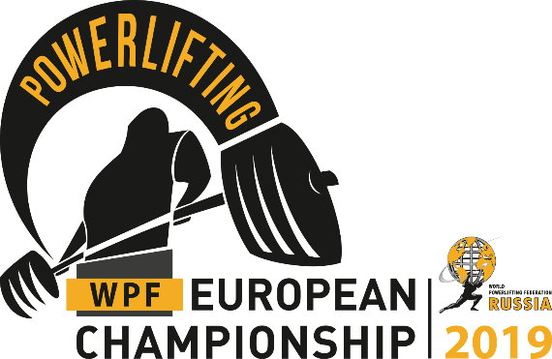

**Yuriy Soloviev** *Meet Director,*

*President Russian Powerlifting Federation*

**Vasiliy Filatov**

*Vice-President Russian Powerlifting Federation*

[wpfpowerlifting@gmail.com](mailto:wpfpowerlifting@gmail.com)

**🕽** **+7-916-185-70-25**

**2019 WPF EUROPEAN CHAMPIONSHIPS**

POWERLIFTING - BENCH PRESS - DEAD LIFT

|  |  |
| --- | --- |
| **Classification:** | WPF with no doping test -WPF  WPF with selective doping test (amateur division) - WPF (am) |
| **Location:** | Technology University Sport Palace, 20 corp.1,  Strominka Street, Moscow, Russia, |
| **Meet Director:** | Yuriy Soloviev, President, Russian Powerlifting Federation |
| **Dates:** | **8th to 9th June 2019** |
| **Lifter Roster and Weigh-In Schedule:** | **Before 15th May 2019** |
| **Categories:** | All WPF Weight Categories & All WPF Age Divisions  All WPF Categories: Raw, Classic Raw, Single-ply, Multi-ply |
| **Entry Fees:** | **First Event - €60 / First Event (with doping test) - €75**  **Second Event - €50 / Second Event (with doping test) - €50**  **Third Event - €40**  **Entry fees are payable on weighing.**  Lifters from **NON** Affiliated Nations will have to pay 50% more entry fee, |
| **Entry Closing Date:** | **15th May 2019.** Applications for participation must be submitted before this date. |
| **To Enter:** | Accepting applications through the website: <https://wpfpowerlifting.ru/en/calendar/132/> |
| **Websites:** | All information will be included on the championships website: [**https://wpfpowerlifting.ru/en/**](https://wpfpowerlifting.ru/en/) |
| **Visa support:** | <http://www.visatorussia.com/> |
| **Hotel info:** | Izmailovo Gamma-Delta <http://www.izmailovo.ru/eng/#fullversion>  Distance from hotel to event place 6.5 km |